Steps to Create a Gurobi Academic License

Before You Start
- Connect to the institute internet (Use the Wi-Fi username and password provided by the institute).

Step 1: Create a Gurobi Account
1. Register using the institute email id at https://portal.gurobi.com/iam/register/ 2. Fill in:
o First Name o Last Name o Country: India o Email address: use the email address provided by the institute o State: UK
- On the “Your Work” page choose “Academic”
- Set the University as “IIT Roorkee”
- For Academic Position set “Student”
- Set Expected graduation year as 2027
- Set Expected graduation month as July 2027
- Set your password
- Verify your account by entering in the OTP you have received in the email
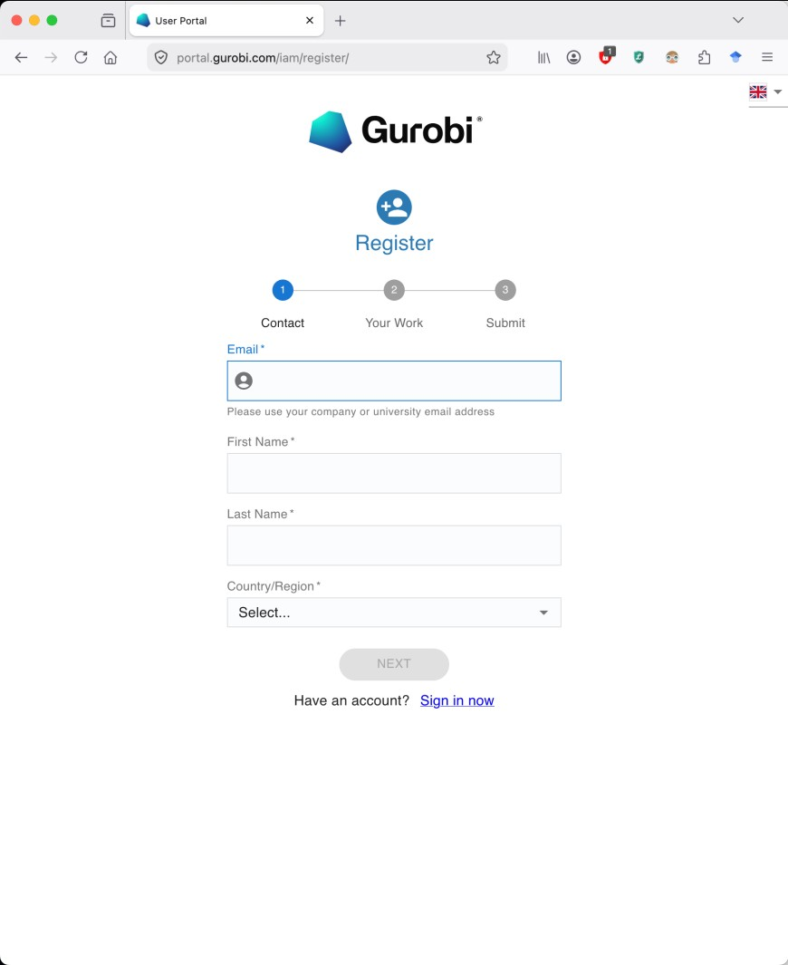

Step 2: Download and Install Gurobi
- After logging in to your gurobi account go to , https://www.gurobi.com/product/download-center/optimizer-software
- Note that this can only be accessed while you are logged in to your account on the Gurobi website.
- Download the correct installer for your operating system:
o Windows o macOS o Linux
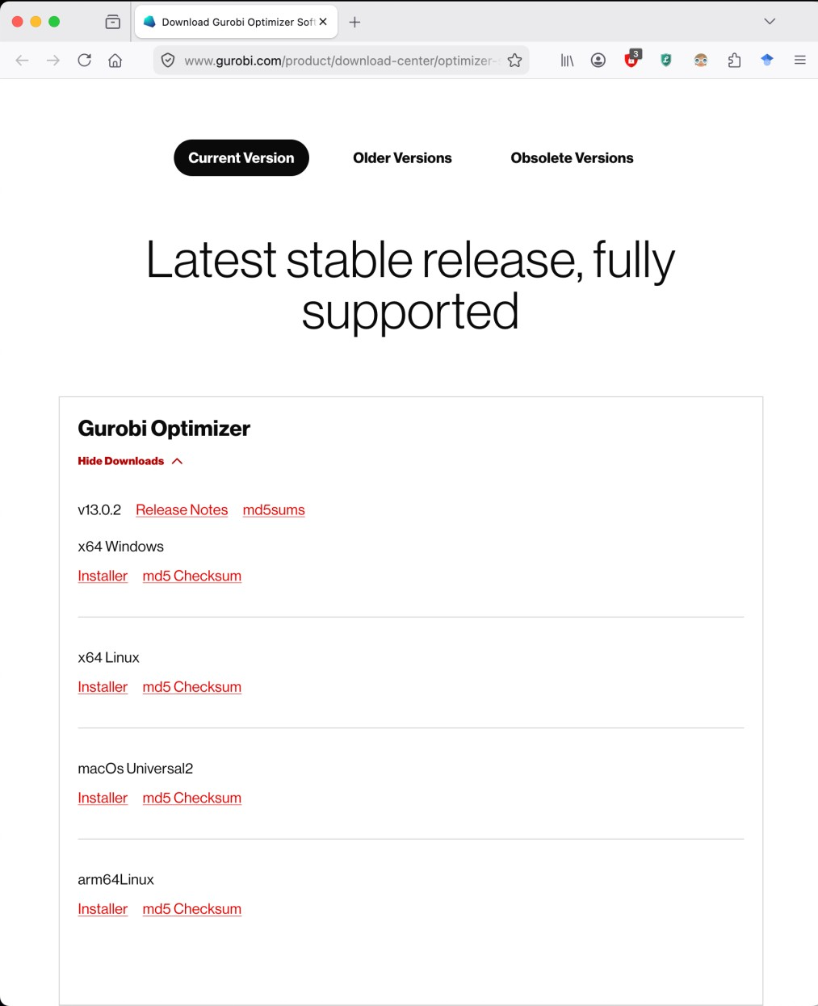
4.

Install Gurobi using the default settings.

Step 3: Request the Academic License
- Log in to your Gurobi account.
- Open the user portal: Gurobi User Portal
- Go to: o Licenses o Request
- Choose:
o Named-User Academic license
- Click Generate Now.
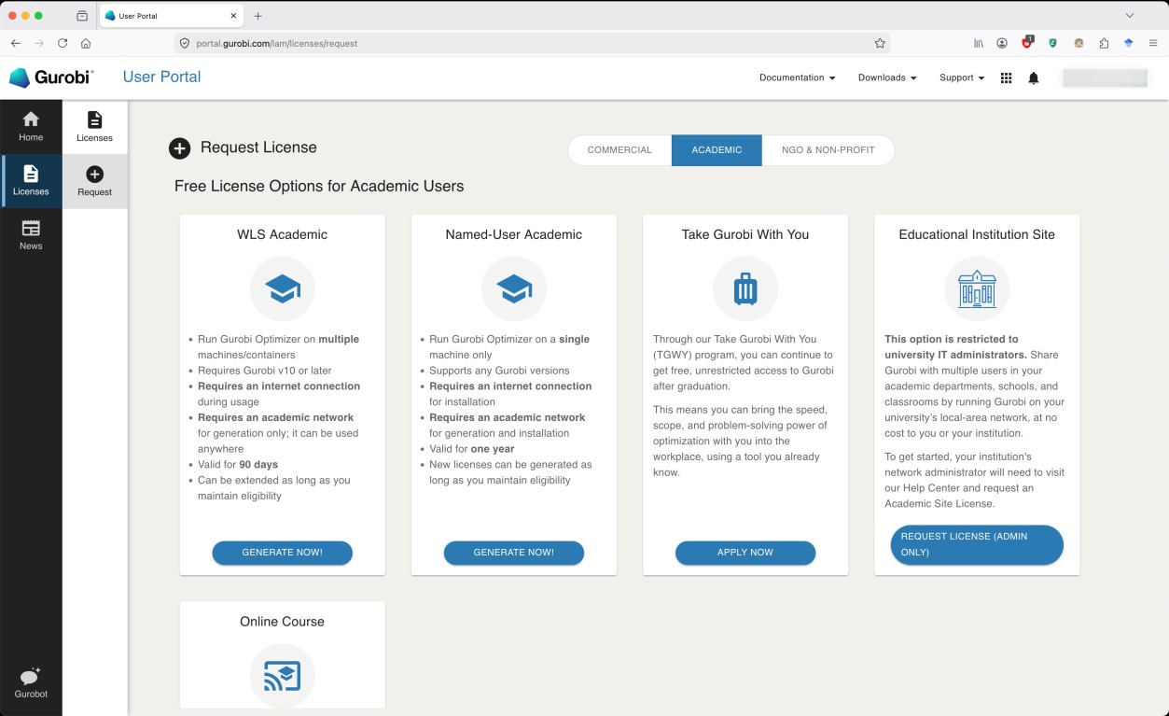

Step 4: Activate the License

After generating the license, Gurobi will show a command like: grbgetkey xxxxxxxx-xxxx-xxxx-xxxx-xxxxxxxxxxxx
Run this command in:
- Terminal (macOS/Linux)
- Command Prompt (Windows)
This downloads and installs the license automatically.

Step 5: Test Installation
Run Python. Install gurobipy and test:
Run the input file:
test.py
If no error appears, the installation is successful.

Step 6: Install gurobipy in VS Code
Run the following in the VS Code terminal:

pip install gurobipy

Important Notes
- You must be connected to the institute network while requesting the license.
- The free academic license is valid for non-commercial academic use only.
- The license is usually valid for 1 year.
- Each participant should create their own account and license.

